 **BANGLADESH UNIVERSITY OF BUSINESS**

**AND TECHNOLOGY (BUBT)**

**Dept. of EEE**

Rupnagar, Mirpur-2, Dhaka-1216, Bangladesh

Phone: PABX-9024266, 9024277, 9015397, 9020132-4, Fax: 9024399

E-mail: [info@bubt.edu.bd](mailto:info@bubt.edu.bd), Website: www.bubt.edu.bd

**EXAMINATION SCRIPT**

(Filled up by class teacher) (This part is filled up by students)

|  |  |  |  |  |
| --- | --- | --- | --- | --- |
| **Question No.** | **Mark Obtained** |  | **Name:** | **Md. Zobayer Hasan Nayem** |
|  |  |  | **Student ID:** | **19202103274** |
|  |  |  | **Intake - Section:** | **44-7** |
|  |  |  | **Program:** | CSE |
|  |  |  | **Course code:** | 121 |
|  |  |  | **Course title:** | CSE 121 |
|  |  |  | **Trimester:** | Summer 2020 |
|  |  |  | **Exam type:** | Mid Term |
|  |  |  | **Date:** | 25 September, 2020 |
| Total Mark |  |  | **Question option:** |  |

Ans To The Que No : 1(A)

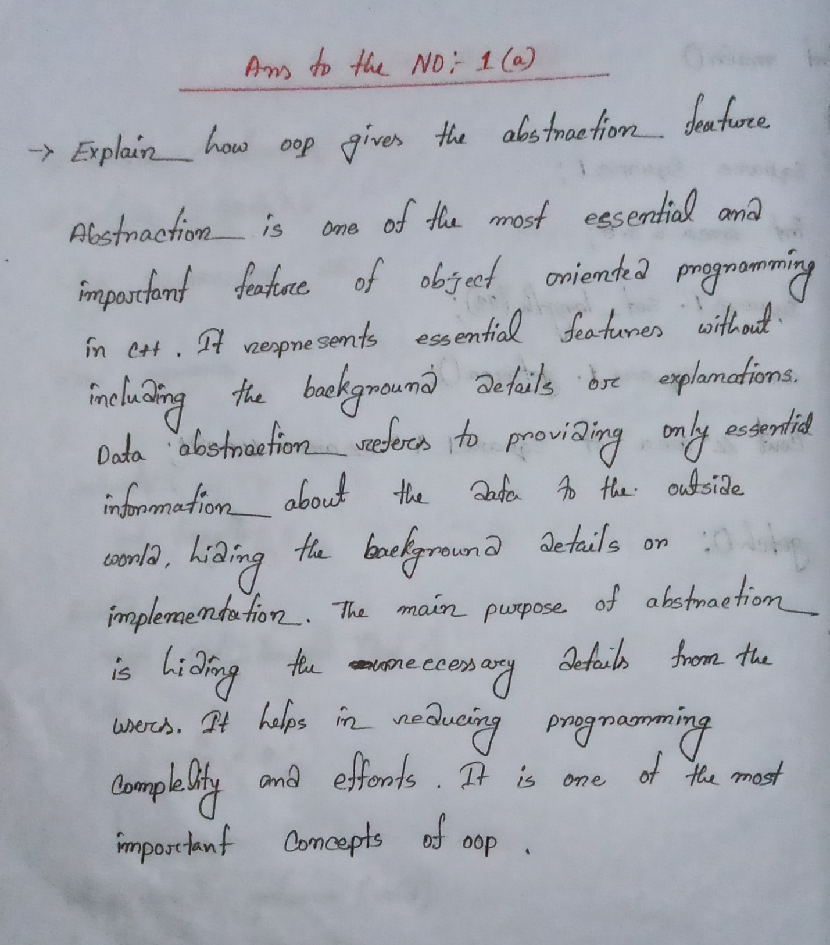

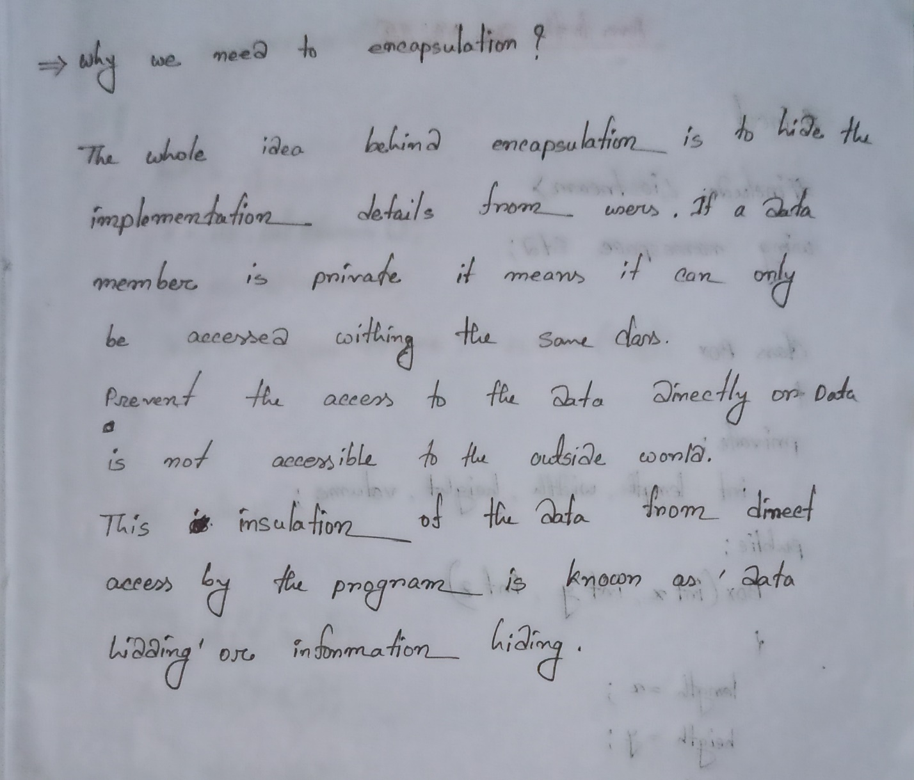

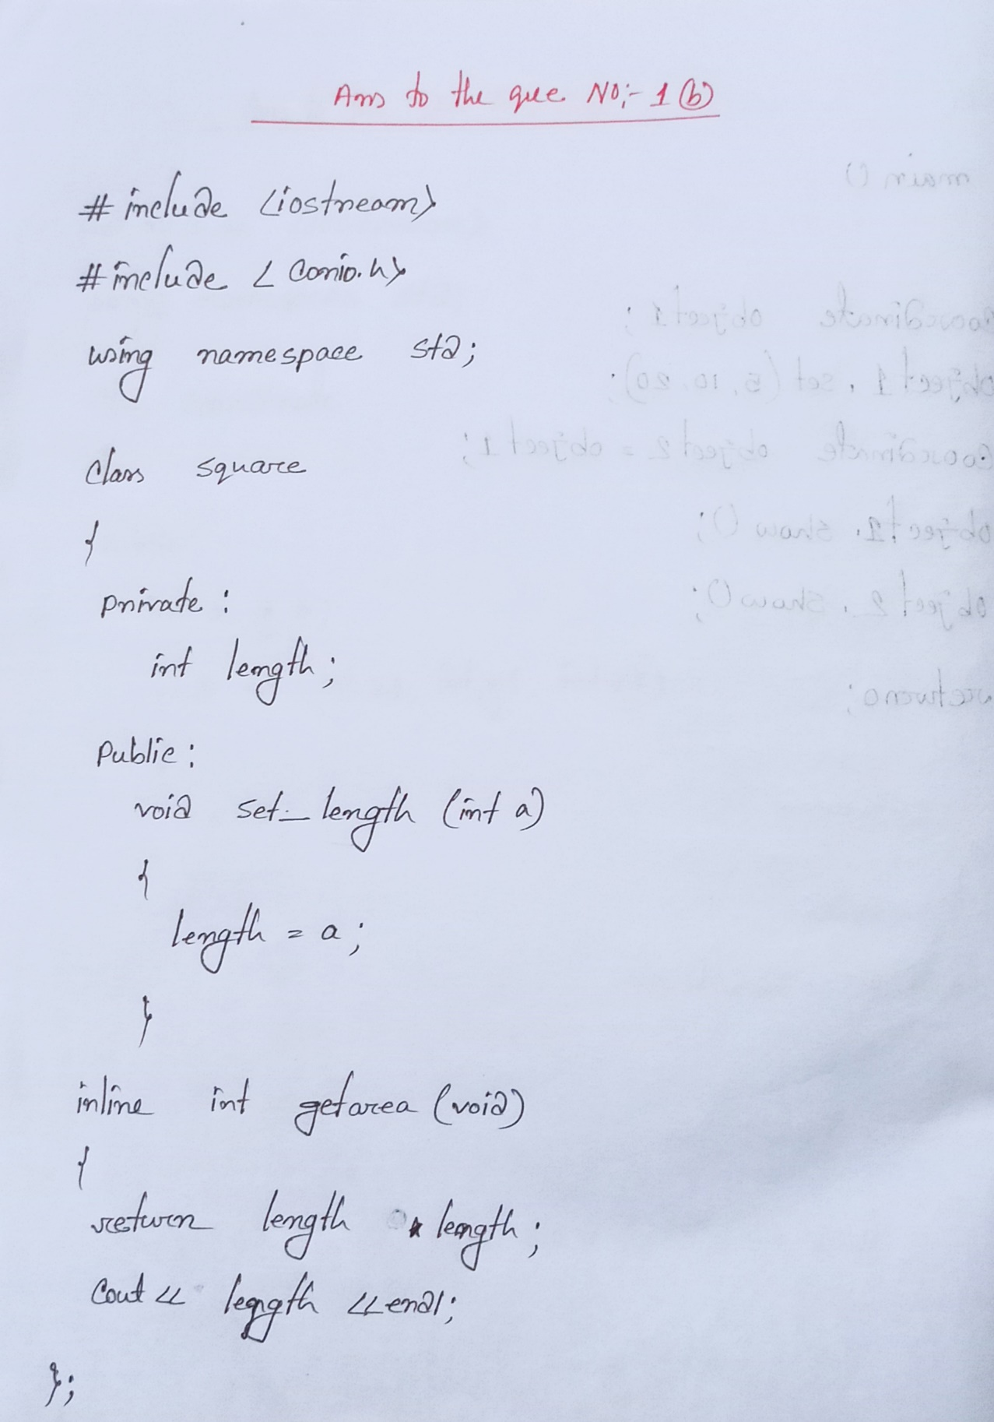 Ans To The Que No : 01(B)

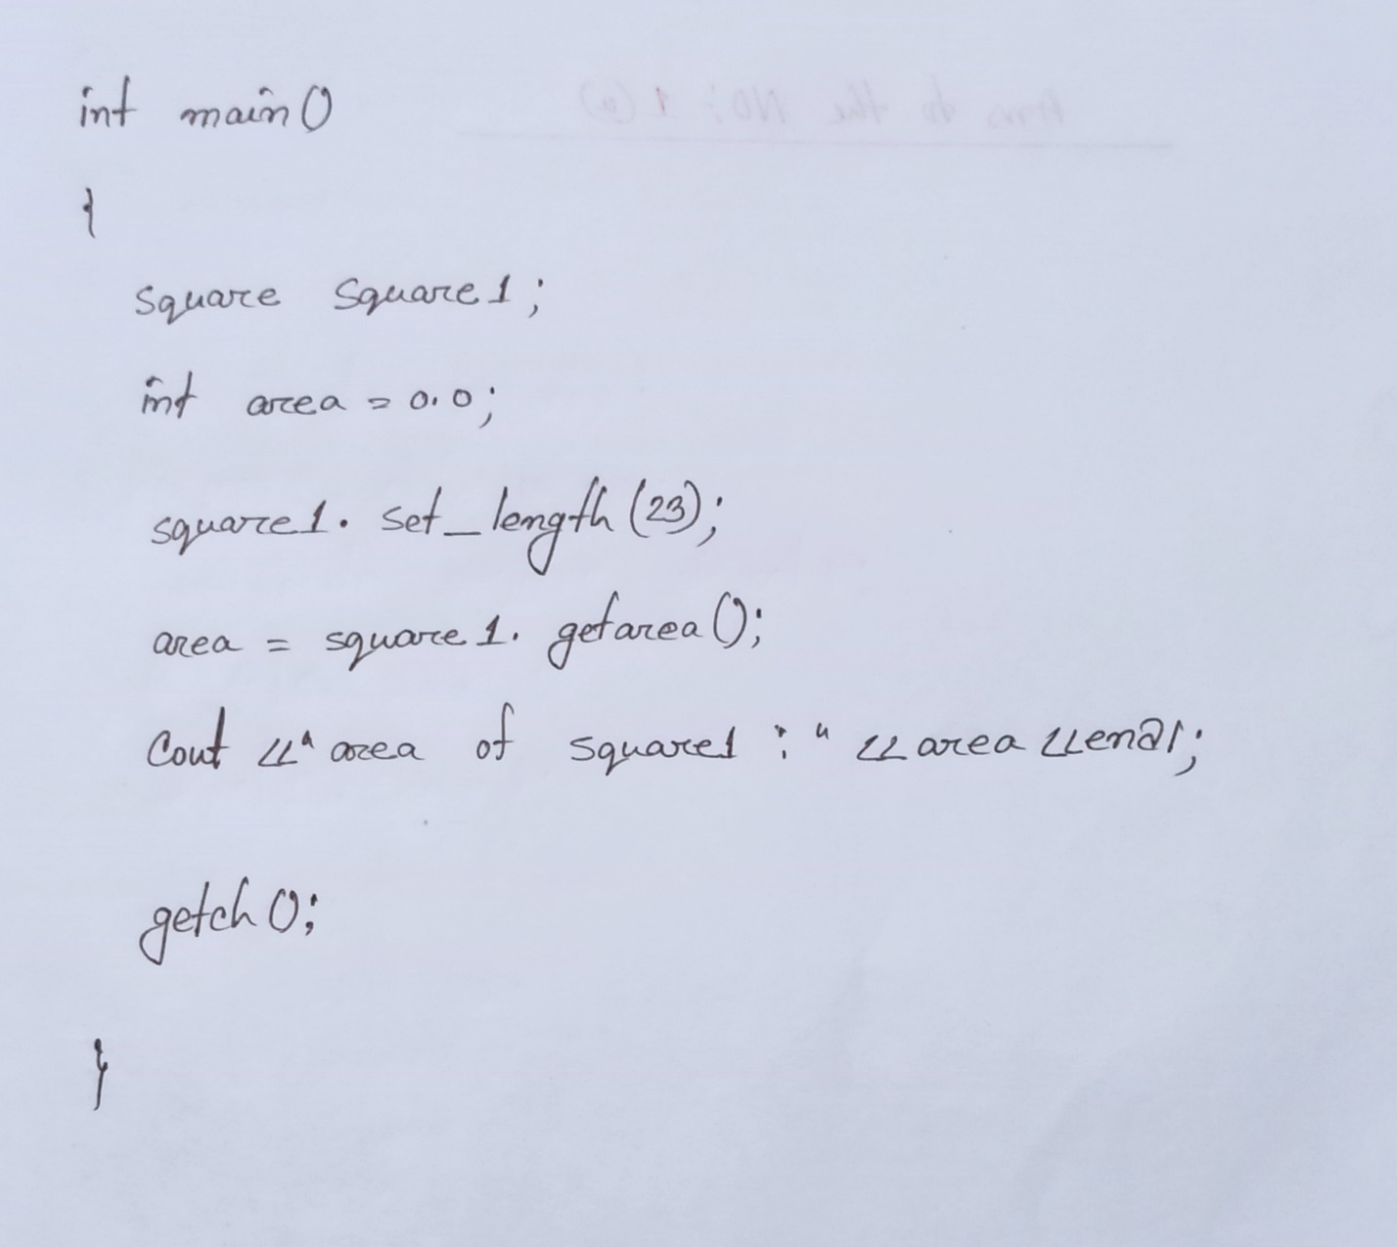

Ans To The Que No: 02 (A)

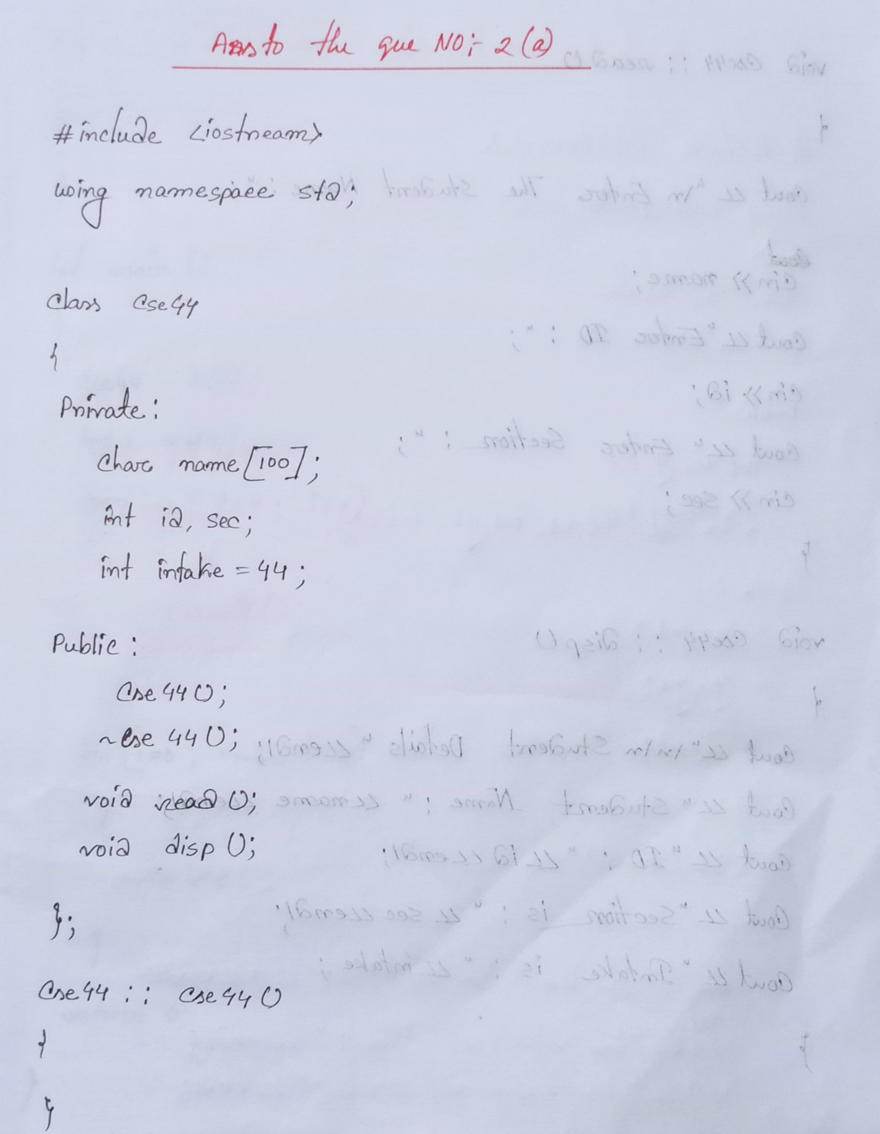

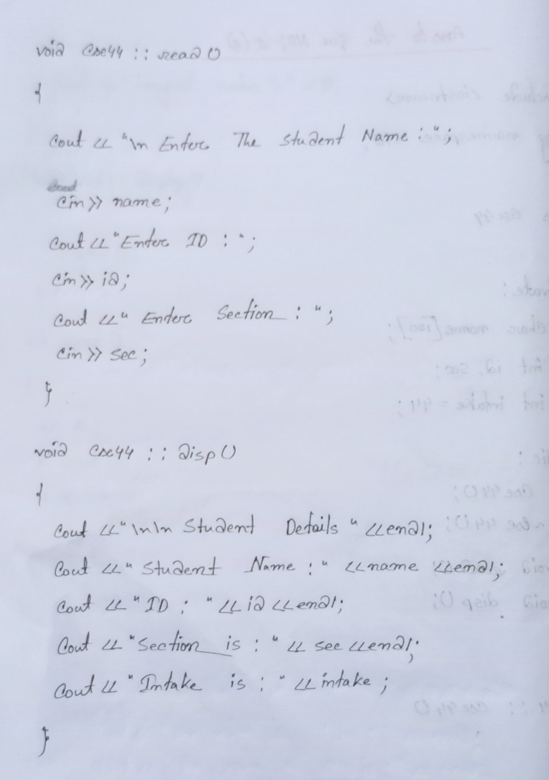

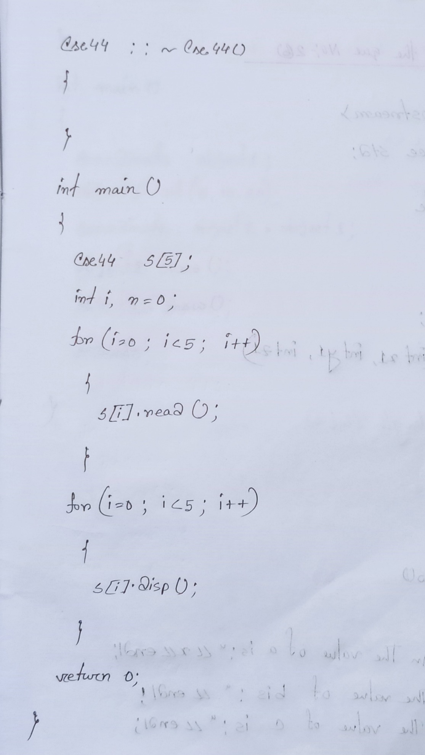

Ans To The Que No : 2-(B)

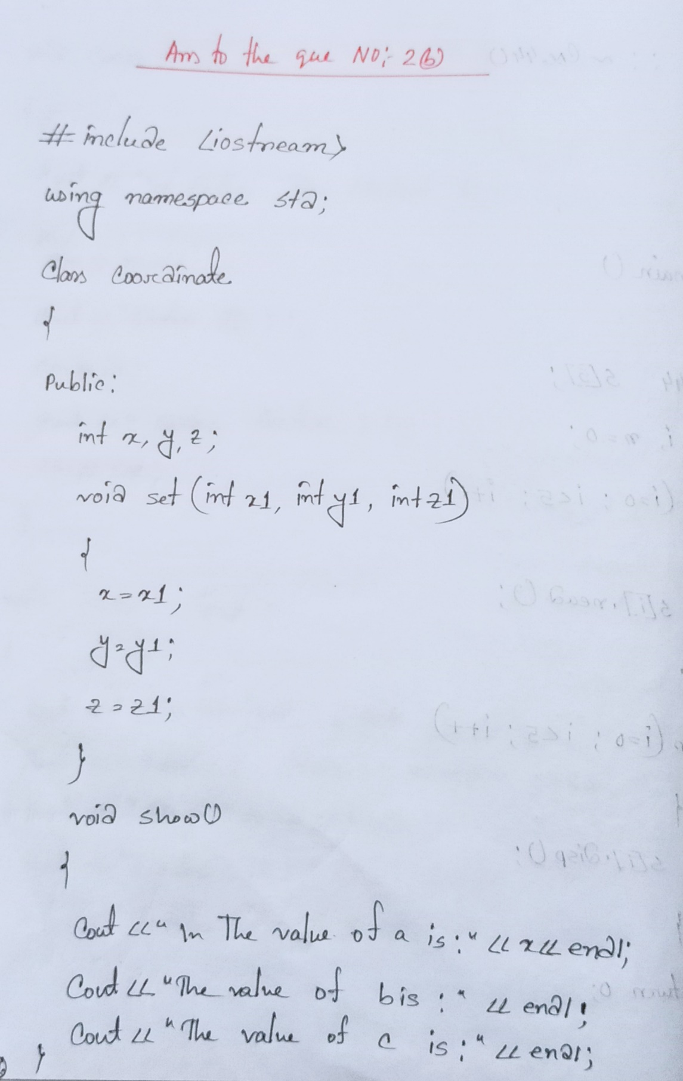

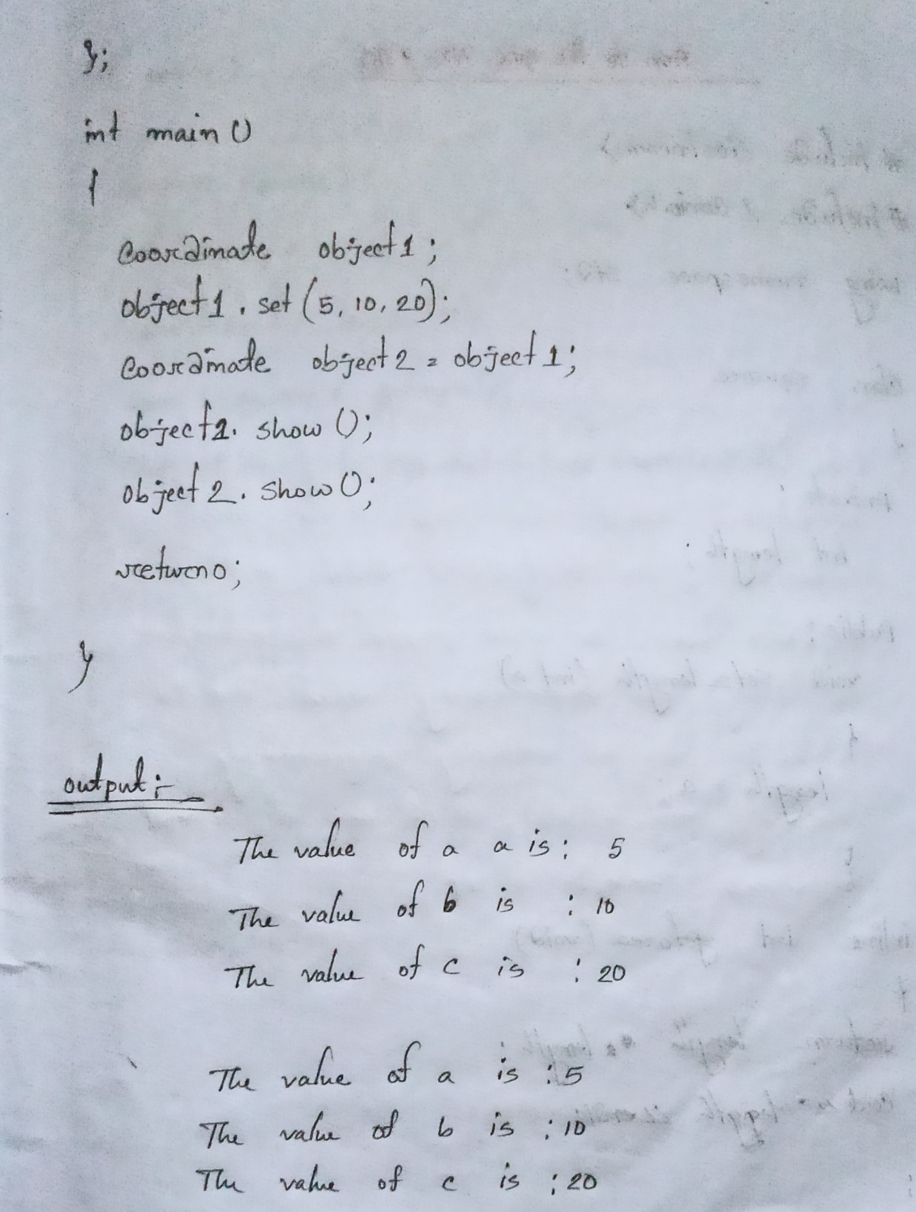

Ans To The Que No: 03 — (A)

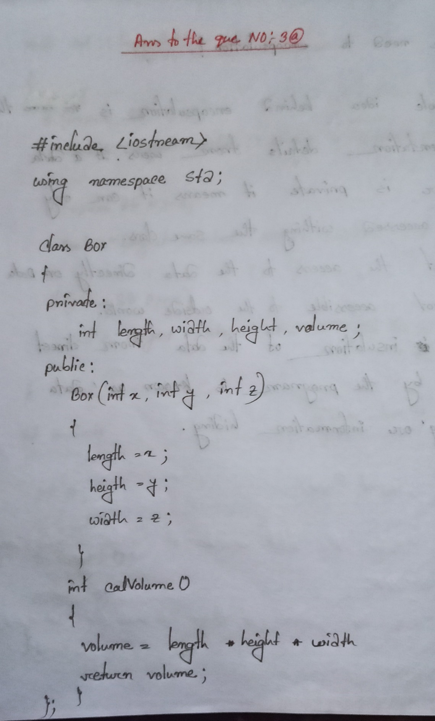

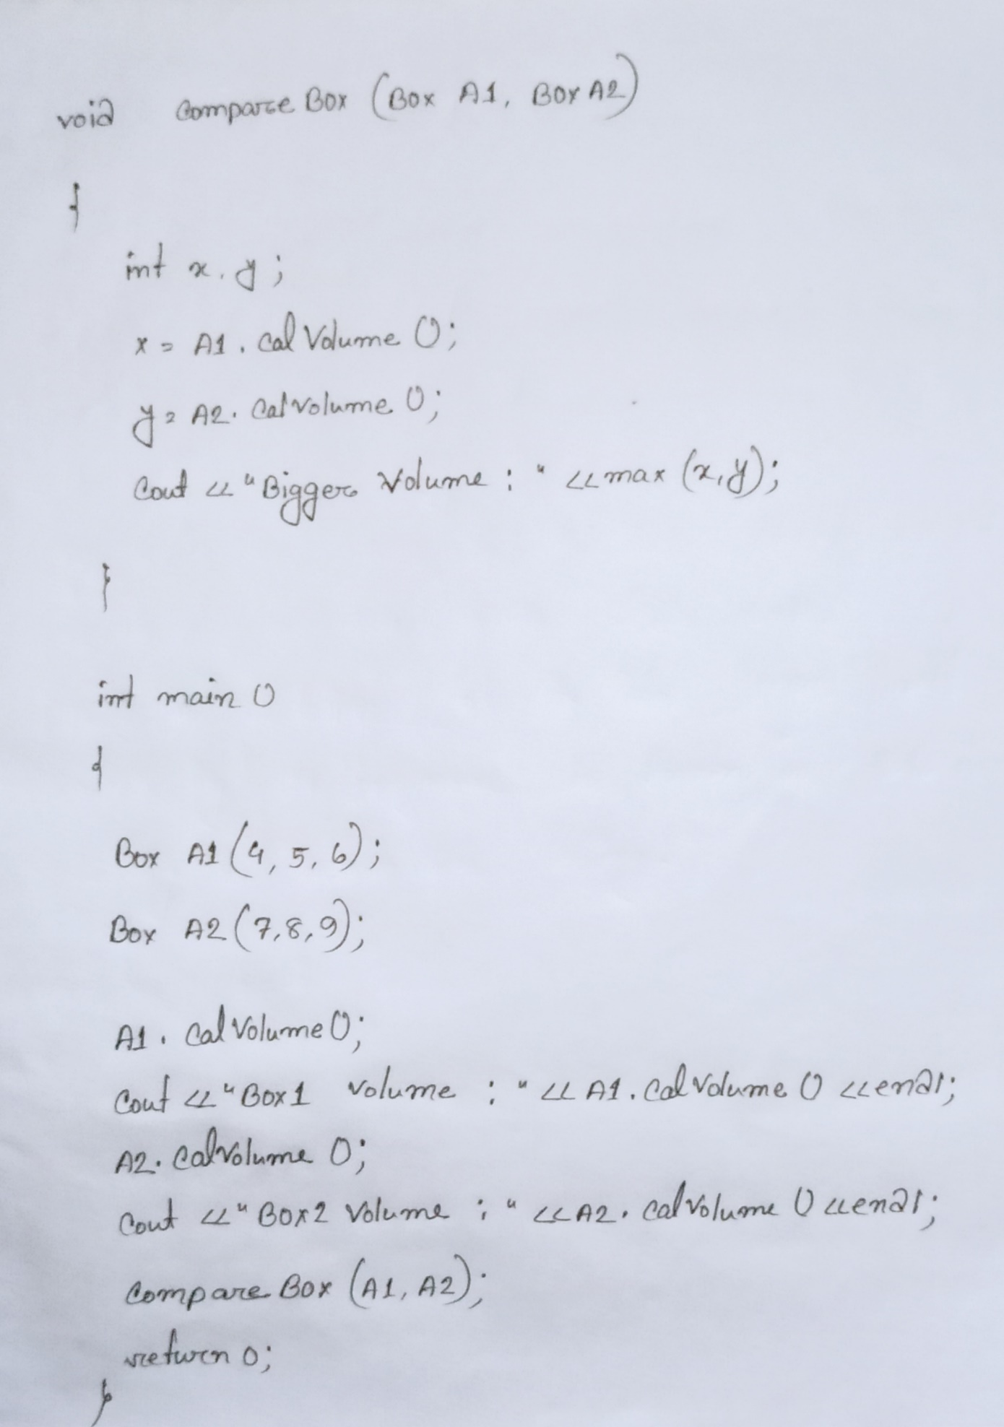

Ans to The Que No : 03 (B)

